**OUR WORK**

**VISION**

To attain a well-nourished community where the underprivileged will not lack the basic feeding need. A society where health related issues will be nipped in the bud by ensuring people feed nourishingly well.

**MISSION**

To reach out to the vulnerables in the society with food materials, drugs and water. Children who lack daily feeding needs are to be properly taken care of. Also to ensure the proper and reliable production of food across all seasons and to ensure proper storage and processing in a bid to ensure food security and prevent wastage.

**OUR MODEL**

Our model is based on human resources development of people especially-the farmers. The approach is centred on educational cum paternalistic. We gave training to rural people who were too poor to attend full-time courses in the University. Top-down teaching methods are employed, but participants of our training are expected to make their own decisions about how to use the knowledge they acquire. We also disseminate the useful information through outreach activities and farmer-to-farmer exchanges.

**ABOUT US**

Feeding the world Inc is a community based Massachusetts Non Governmental Organisation. We are non profit making and we are not political.

We are focused on feeding the vulnerables in the communities. We are concerned about spate of disease and untimely death which might likely arise from poor feeding and malnourishment.

**PROGRAMMES**

We embark on serious agricultural drive which covers the scope of food production, food processing and storage.

Feeding the World Inc organises free agricultural extension programme where we train the peasant and commercial farmers on improved agricultural practices. Our Agricultural Extension Programme stretches to the provision of improved viable seeds, genetically improved animals and above all the needed technologies to put them to work.

We identified drudgery as one of the bane of agricultural developments, hence the need to provide farm machineries for the farmers, especially the one in the rural areas.

Another scope of our programme is the provision of credit facilities to the poor farmers. This involves the provision of soft loans for the farmers in order to improve their production.

**CONTACT US**

**We always love to hear from you.**

Remember: We do not rent, sell, or share email addresses with any third party or organization!

49 Franklin Street, Somerville, MA 02145

Email: [feedingtheworld@yahoo.com](mailto:feedingtheworld@yahoo.com)

Telephone: +1 607 882 3492

**GOVERNANCE**

1. **BOARD OF TRUSTEES**

Board of Trustees are volunteers who serve without pay. At Feeding the World Inc., we believe that Leadership is a matter of intelligence, trustworthiness, humaneness, courage, and discipline.

Feeding The World Inc. appreciates characteristics of well-functioning teams:

Purpose: Board proudly share a sense of why the team exists and are invested in accomplishing its mission, vision and goals.

* Priorities: Board know what needs to be done next, by whom, and by when to achieve team goals.
* Roles: Board know their roles in getting tasks done and when to allow a more skilful member to do a certain task.
* Decisions: Authority and decision-making lines are clearly understood.
* Conflict: Conflict is dealt with openly and is considered important to decision-making and personal growth.
* Personal traits: Board of Trustees feel their unique personalities are appreciated and well utilized.
* Norms: Group norms for working together are set and seen as standards for everyone in the groups.
* Effectiveness: Board Members find team meetings efficient and productive and look forward to this time together.
* Success: Members know clearly when the team has met with success and share in this equally and proudly.
* Training: Opportunities for feedback and updating skills are provided and taken advantage of by Board of Trustees and team members.

1. President General

Mr. Adisa Kabiru Adeniyi, FCA, AMNIM

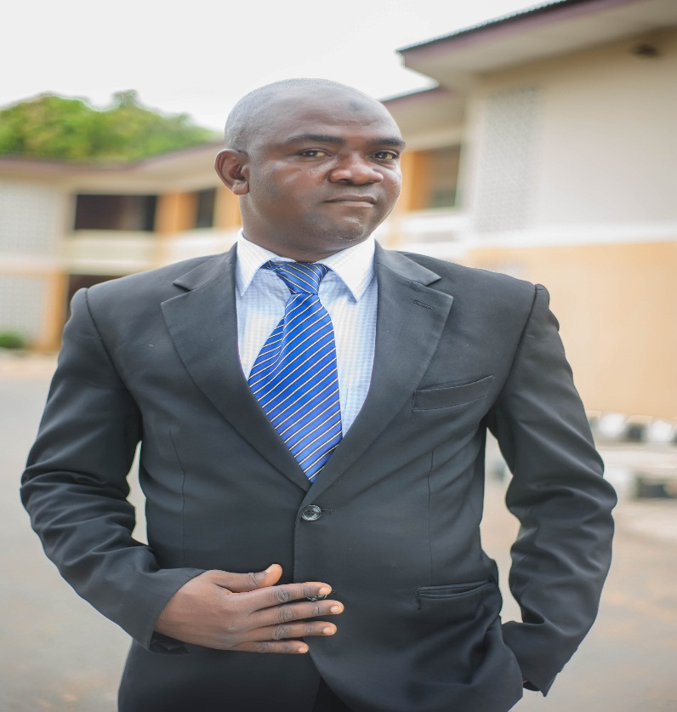

2. Secretary

Mr. Asafa Mukaila Olukayode

BSc Agricultural Engineering, Msc. Agricultural Engineering



3. Board Member

Mr. Shittu ‘Raman Ayodele

HND, PGDE.

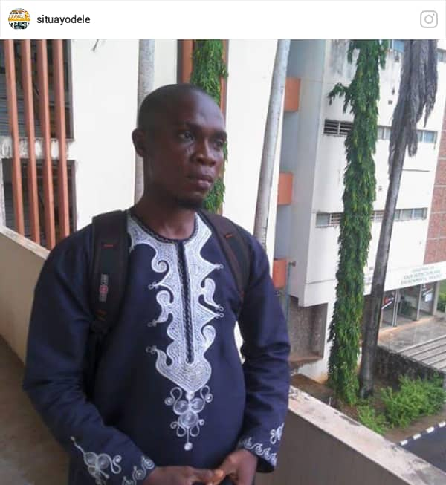

4. Treasurer

Ganiyu Wakilat Aderonke

HND

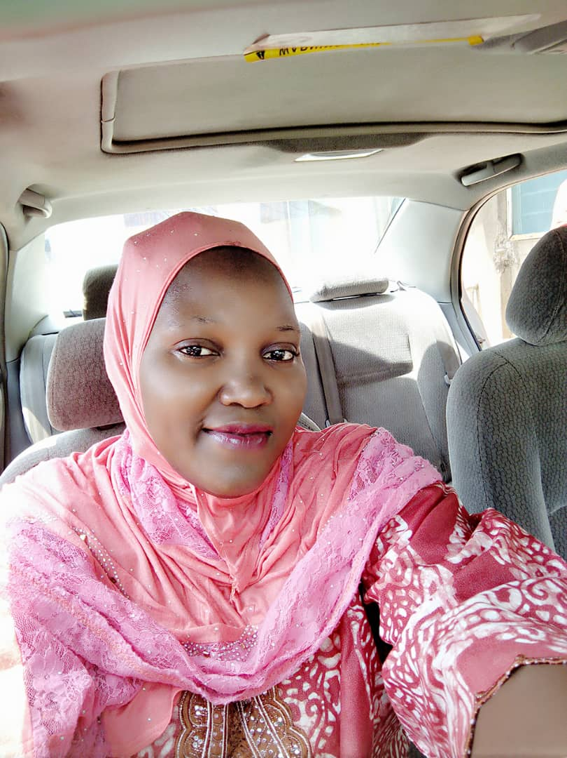

## 5. Board Member

## Dr Olanrewaju Moshood Omotayo **Ph.D.**

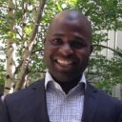

**ii. TRANSPARENCY**

To increase transparency, Feed The World Inc. actively infuse greater disclosure, clarity, and accuracy into their communications with [stakeholders](https://en.wikipedia.org/wiki/Project_stakeholder) through [radical transparency](https://en.wikipedia.org/wiki/Radical_transparency). Accountability and transparency are of high relevance at Feeding The World Inc. to our donors and sponsors.

Feeding The World Inc. has a zero-tolerance policy on funds diversion, misappropriation and mismanagement. We have a reputation for maintaining prudence and efficient use of our partners’ donations. We utilize a sound tracking and Monitoring and Evaluation system and makes available to everyone the impact of our interventions.

**iii. PRIVACY POLICY**

Feeding The World Inc. located at 49 Franklin Street, Somerville, MA 02145 does not trade, share, rent, trade, exchange, market, swop or otherwise disclose donor information to any outside party. Feeding The World also has a policy of not sending mail to donors on behalf of other organizations.

**donation policy**

All donations received by Feeding The World Inc. are used for purposes and expenses related to events and programmes for which they are intended and solicited. For general donations, Feeding The World Inc. may use your contribution wherever most needed

**INFORMATION GATHERING**

Feeding The World Inc. will only provide you communications and updates that you request for and will not send you promotional materials without subscription. By subscribing to our periodic communications via email, physical address or telephone number, Feeding The World Inc. will only send regular membership communications, as detailed on the sign-up form, if you elect to receive them. Subscribers have the option of making the details of their donations public or private.

###### **Secure Payments**

All credit card, paypal and personal profile information provided to Feeding The World through its Internet software partner is safe, faster, more secure way to donate online with, your payment is sent directly to the vulnerable like farmers and children.

Feeding The World Inc. collects information in one way:

Information you provide online: By donating to Feeding The World Inc. or signing up for email updates, the information you volunteer includes your name, phone number and email address.

**ACCREDITATION**

EIN: 83-2357572

**FINANCIALS**

**donation policy**

Feeding The World Inc. solicit for donation in a respectful manner and without pressure and demonstrate greater accountability by showing donors the direct impact of their donation.

Feeding The World Inc. accept: gifts of cash, marketable securities, stock in privately owned companies, real estate, tangible personal property and pledge

**TRAINING AND CERTIFICATION**

WHY YOU SHOULD ATTEND OUR TRAINING

Farming is an accident practice that have kept people alive for thousands of years, and with today’s technology it is a diverse and invigorating area to be involved in. If you are considering training or vocation but not quiet convince yet, have a look at our reasons why you should. The following subjects are well covered during our training:

1. Animal Health
2. Food Security
3. Integrated Pest Management
4. Community Development/Rural Sociology
5. Farmers’ Cooperative
6. Leadership
7. Home Economics
8. Crop Plantation (selected crops)
9. Poultry Production
10. Programme Planning and Evaluation
11. Farm Management

|  |
| --- |
| ENROL FOR THE TRAINING |

|  |  |
| --- | --- |
| EMAIL | PHONE NUMBER |

GET INVOLVED

Volunteer

Get Involved in your area

Join us at one of our international locations and help prepare materials for distribution to communities in need.

Depending on the location and situation, tasks may include:

* Reception and sorting of donated items
* Facilitating product distributions
* Assisting with special events like rallies, advocacy visits, International Day Celebrations, Research, etc
* Resource mobilization
* Planning conference, seminar, training and workshop.

Volunteer as an individual, or register for a group activity.

### **Select a Location**

|  |
| --- |
| Somerville |

**FUNDRAISING**

Rising Fund for Feed The World Inc

* Raise fund for Feeding The World Inc. through Facebook during your birthday
* Raise fund for Feeding The World Inc. through online platforms
* Organise events like Marathon to raise fund for Feeding The World Inc.

Donate Sponsor a Farmer

## Shine bright in a farmer’s life.

Your gift empowers people out of poverty and feed two billion more people by 2050.

Donate

|  |  |  |  |  |  |  |  |
| --- | --- | --- | --- | --- | --- | --- | --- |
| $50 | $100 | $150 | $200 | $250 | OR |  | GIVE NOW |

Giving monthly is the most powerful ways to donate

|  |  |  |  |  |  |
| --- | --- | --- | --- | --- | --- |
| $15 | $30 | $60 | $90 | OR | GIVE NOW |

Empower people out of poverty for good. When you give where it’s needed most you’ll help farmers and communities rise above poverty. Because it’s life-changing when you finally have clean water, get the right kind of food and feel safe. F

The most basic need of life is food and the most evident manifestation of poverty is hunger. Giving resources to support rural communities is a fast way to help rural dwellers who are predominantly farmers to get out of the viscous circle of poverty and help the world get closer to food sustainability.

## **MORE WAYS TO GIVE**

Sponsor a Farmer with Feeding The World Inc.

Sponsoring a farmer is a personal way to your quota to feed two billion more people by 2050.   
For $49 a month, you'll help farmers and their community to stand tall, free from shortage of food.

|  |  |  |  |  |  |  |
| --- | --- | --- | --- | --- | --- | --- |
| Location | Gender | Age | Birth Month | Birthday | Type of Farming | Clear All |

# GIFT CATALOG

Give a gift. Change a life.

Giving is life. Sharing is a behaviour.

Help farmers. Help the world.

Help children and families in need.

Honor loved ones with a free personalized card

Shine bright Empower people out of poverty for real. For Good Give Now

X One Time X Monthly X Yearly

|  |  |  |  |  |  |  |  |  |
| --- | --- | --- | --- | --- | --- | --- | --- | --- |
| $50 | $100 | $150 | $200 | $250 | OR | $ |  | GIVE NOW |

# Empower a farmer; liberate a community. Helping people get out of poverty is not choice; it s a necessity meant to guarantee the sustainability of our world. When you give to vulnerable communities, you’ll help farmers and children rise above poverty by ensuring access to clean water, good food and shelter.

### Monthly donation is an efficient way to make a difference!

* **Monthly giving is an easy and effective routine to help poor children and their communities.** Your donation will be prudently utilised wherever they’re needed the most, to fulfil the day and protect the tomorrow of children in vulnerable farming communities.
* **Hear success stories and read impact assessment about how your donation has helped to make a difference. Our periodic bulletins showcase wonderful stories of how little donations have helped change the fate of farming families; thus giving you a feel of fulfilment and the desire to give more.**

### **Gifts that Multiply**

Power up your impact by giving gifts that multiply due to government grants and donation from generous corporations.

GIVE NOW

Millions of people across East Africa are experiencing chronic hunger as a result of famine caused by conflict, recurrent extreme drought, and high food prices. Over 800,000 people are internally and externally displaced due to violence in south Ethiopia since the beginning of 2018 and are in desperate need of support. About 22 million people in East African Countries especially South Sudan, Somalia, and Ethiopia are equally facing high levels of food insecurity. 9 million children are in need of nutrition assistance in these countries.

Recurring East Africa droughts make it difficult for farmers and herders to produce crops and feed livestock. Seasonal rainfall has been above average in some places, and excessive amounts of rain falling on drought-stricken land have resulted in flash floods, killing more than 300 people and washing away crops and shelters.

Children are the worst affected, with their health and development drastically impacted. More than 15 million children in Ethiopia, Kenya, South Sudan, and Somalia are struggling to get enough to eat. Floods are increasing the risk of cholera and other water-related diseases among people with temporary shelter and poor sanitation.

## Extreme hunger. Drought. Conflict. Help children and families in East Africa.

|  |  |  |  |  |  |  |  |  |
| --- | --- | --- | --- | --- | --- | --- | --- | --- |
| $50 | $100 | $150 | $200 | $250 | OR | $ |  | GIVE NOW |

**RECEIVED ALERT**

|  |  |  |
| --- | --- | --- |
| Email address | Telephone Number | Signup |

###### **REAL ESTATE.**

Gifts of real estate may be accepted by Feeding The World Inc. Feeding The World Inc review of gifts of real estate shall include, but not be limited to, legality, title, encumbrances, liens, mortgages, easements, restrictions, and environmental issues. Until the real estate or property is sold and proceeds are deposited into the Feeding The World Inc.’s account, all legal obligations related to ownership of the real estate such as taxes, insurance, utilities and security shall remain with the donor.

###### MARKETABLE SECURITIES.

Feeding The World Inc. Will accept gifts of publicly traded securities, stocks and bonds. Stock with a brokerage firm may be transferred to Feeding The World’s brokerage account by first calling our Relationship Development staff at +1 607 882 3492 in order to receive specific instructions for such a transfer. To donate stock that is held in certificate form, Feeding The World Inc. must be notified in advance so that specific instructions can be provided to the donor.

NEXT STEPS

Contact Dr Moshood Olanrewaju Omotayo or feedingtheworld@yahoo.com to discuss the possibility of giving real estate to Feeding The World Inc.

Seek the advice of your financial or legal advisor to make sure this gift fits your goals.

If you include Feeding The World in your plans, please use our legal name and Federal Tax ID.

Legal Name: Feeding The World Inc.

Address: 49 Franklin Street, Somerville, MA 02145

Federal Tax ID Number:

Frequently Asked Questions

1 Question: Does my donation go directly to a farmer?

Question: As a farmer sponsor, you’re connected with one specific farmer. But sponsored farmer do not receive direct cash benefits. Your monthly donation is pooled for maximum effectiveness – meaning sponsored farmer do not receive funds directly. You join forces with other sponsors to fund long-term community development programs that benefit your farmer and other vulnerable farmers in their community.

 2. Question: How does this programme work?

Answer: Feeding The World Inc. is based on human resources development of people especially-the farmers. It is inputs based system where farmers are provided with almost everything they need to succeed from ploughing, seed, fertilizer, herbicide to harvest.

3. Question: As a beneficiary, how do you help, can I collect cash to expand my farm?

Answer: Feeding The World Inc. don’t give cash to farmer but provide all inputs in need so as to add value to an agricultural products.

4. Question: What is the value your organisation trying to add to value chain?

Answer: Feeding The World Inc programmes centred on development and dissemination of plant and animal material, input supply, farmer organization, farm production, post-harvest handling, processing, provision of technologies of production and handling, grading criteria and facilities, cooling and packing technologies, post-harvest local processing, industrial processing, storage, transport, finance, and feedback from markets.

5. Question: Who is eligible to apply for Feeding The World Inc Inputs Grant?

Answer: All the farmers are eligible to apply for a Feeding The World Inc grant. They include:

·         Input suppliers

·         Smallholder Farmers and Farmer Groups

·         Large Scale Primary Producers

·         Agricultural Processors

·         Integrated Farms

·         Agricultural Logistics Providers

·         Agro-dealers, Input and Equipment Suppliers

6. Question: Is it a must to attend training before applying for grant?

Answer: Attending training is one of perquisite. You have to attain training before applying for grant.